Design Principles and Patterns
Exercise 1: Implementing the Singleton Pattern
using System;

class Logger
{
private static Logger? instance;

private Logger() { }

public static Logger GetInstance()
{
if (instance == null)
instance = new Logger();

return instance;
}

public void Log(string message)
{
Console.WriteLine($"LOG: {message}");
}
}

class Program
{
static void Main()
{
Logger logger1 = Logger.GetInstance();
Logger logger2 = Logger.GetInstance();

logger1.Log("Application Started");
logger2.Log("User Logged In");

Console.WriteLine(logger1 == logger2
? "Both objects are same"
: "Objects are different");
}
}Output-
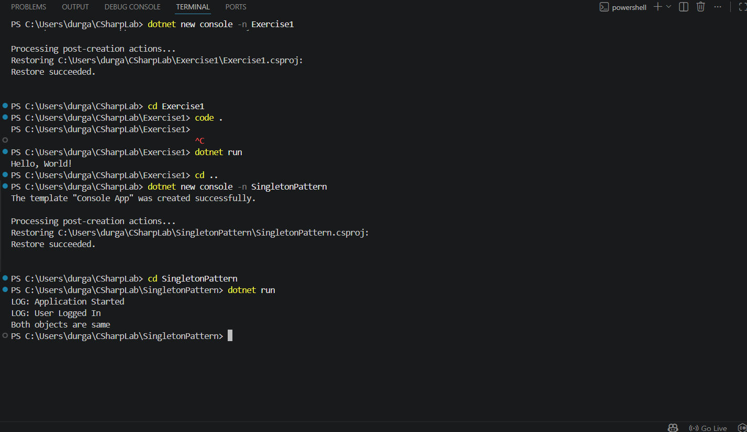
Exercise 2: Implementing the Factory Method Pattern
using System;

interface IDocument
{
void Open();
}

class WordDocument : IDocument
{
public void Open()
{
Console.WriteLine("Opening Word Document");
}
}

class PdfDocument : IDocument
{
public void Open()
{
Console.WriteLine("Opening PDF Document");
}
}

abstract class DocumentFactory
{
public abstract IDocument CreateDocument();
}

class WordFactory : DocumentFactory
{
public override IDocument CreateDocument()
{
return new WordDocument();
}
}

class PdfFactory : DocumentFactory
{
public override IDocument CreateDocument()
{
return new PdfDocument();
}
}

class Program
{
static void Main()
{
DocumentFactory factory1 = new WordFactory();
IDocument doc1 = factory1.CreateDocument();
doc1.Open();

DocumentFactory factory2 = new PdfFactory();
IDocument doc2 = factory2.CreateDocument();
doc2.Open();
}
}Output-

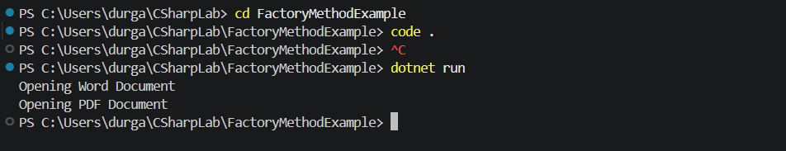
Exercise 3: Implementing the Builder Pattern
using System;

class Computer
{
public string CPU;
public int RAM;
public int Storage;

public class Builder
{
private Computer computer = new Computer();

public Builder SetCPU(string cpu)
{
computer.CPU = cpu;
return this;
}

public Builder SetRAM(int ram)
{
computer.RAM = ram;
return this;
}

public Builder SetStorage(int storage)
{
computer.Storage = storage;
return this;
}

public Computer Build()
{
return computer;
}
}

public void Display()
{
Console.WriteLine("CPU: " + CPU);
Console.WriteLine("RAM: " + RAM + " GB");
Console.WriteLine("Storage: " + Storage + " GB");
}
}

class Program
{
static void Main()
{
Computer gamingPC = new Computer.Builder()
.SetCPU("Intel i9")
.SetRAM(32)
.SetStorage(1000)
.Build();

gamingPC.Display();
}
}Output-
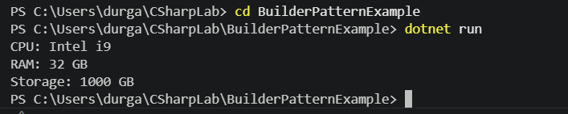
Exercise 4: Implementing the Adapter Pattern
using System;

interface IPaymentProcessor
{
void ProcessPayment(double amount);
}

class PayPalGateway
{
public void SendPayment(double amount)
{
Console.WriteLine("Paid ₹" + amount + " using PayPal");
}
}

class StripeGateway
{
public void MakePayment(double amount)
{
Console.WriteLine("Paid ₹" + amount + " using Stripe");
}
}

class PayPalAdapter : IPaymentProcessor
{
private PayPalGateway paypal;

public PayPalAdapter(PayPalGateway paypal)
{
this.paypal = paypal;
}

public void ProcessPayment(double amount)
{
paypal.SendPayment(amount);
}
}

class StripeAdapter : IPaymentProcessor
{
private StripeGateway stripe;

public StripeAdapter(StripeGateway stripe)
{
this.stripe = stripe;
}

public void ProcessPayment(double amount)
{
stripe.MakePayment(amount);
}
}

class Program
{
static void Main()
{
IPaymentProcessor paypal =
new PayPalAdapter(new PayPalGateway());

IPaymentProcessor stripe =
new StripeAdapter(new StripeGateway());

paypal.ProcessPayment(1000);
stripe.ProcessPayment(2000);
}
}
Output-
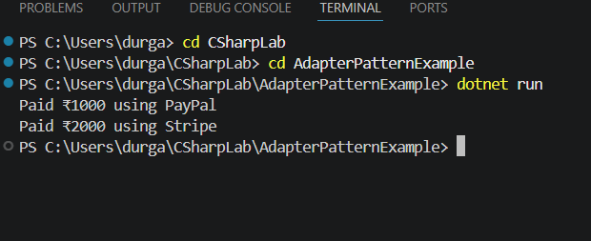
Exercise 5: Implementing the Decorator Pattern
using System;

interface INotifier
{
void Send();
}

class EmailNotifier : INotifier
{
public void Send()
{
Console.WriteLine("Sending Email Notification");
}
}

class SMSDecorator : INotifier
{
private INotifier notifier;

public SMSDecorator(INotifier notifier)
{
this.notifier = notifier;
}

public void Send()
{
notifier.Send();
Console.WriteLine("Sending SMS Notification");
}
}

class SlackDecorator : INotifier
{
private INotifier notifier;

public SlackDecorator(INotifier notifier)
{
this.notifier = notifier;
}

public void Send()
{
notifier.Send();
Console.WriteLine("Sending Slack Notification");
}
}

class Program
{
static void Main()
{
INotifier notifier = new EmailNotifier();

notifier = new SMSDecorator(notifier);
notifier = new SlackDecorator(notifier);

notifier.Send();
}
}
Output-
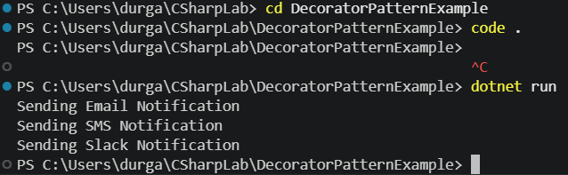
Exercise 6: Implementing the Proxy Pattern
using System;

interface IImage
{
void Display();
}

class RealImage : IImage
{
private string fileName;

public RealImage(string fileName)
{
this.fileName = fileName;
LoadFromDisk();
}

private void LoadFromDisk()
{
Console.WriteLine("Loading " + fileName);
}

public void Display()
{
Console.WriteLine("Displaying " + fileName);
}
}

class ProxyImage : IImage
{
private string fileName;
private RealImage realImage;

public ProxyImage(string fileName)
{
this.fileName = fileName;
}

public void Display()
{
if (realImage == null)
{
realImage = new RealImage(fileName);
}

realImage.Display();
}
}

class Program
{
static void Main()
{
IImage image = new ProxyImage("sample.jpg");

Console.WriteLine("Image created");

image.Display();
image.Display();
}
}
Output-
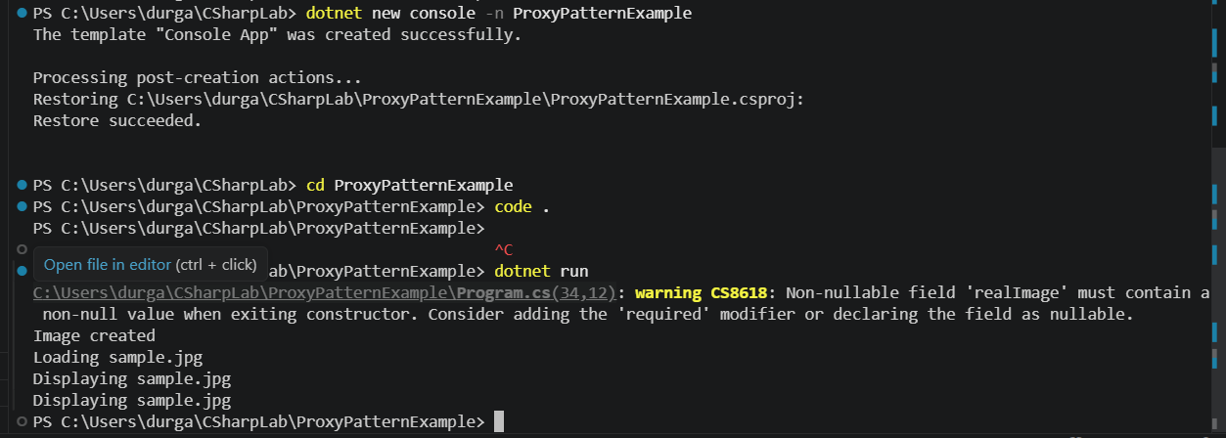
Exercise 7: Implementing the Observer Pattern
using System;
using System.Collections.Generic;

interface IObserver
{
void Update(string stock, double price);
}

class MobileApp : IObserver
{
public void Update(string stock, double price)
{
Console.WriteLine("Mobile App: " + stock + " price updated to " + price);
}
}

class WebApp : IObserver
{
public void Update(string stock, double price)
{
Console.WriteLine("Web App: " + stock + " price updated to " + price);
}
}

class StockMarket
{
private List<IObserver> observers = new List<IObserver>();

public void Register(IObserver observer)
{
observers.Add(observer);
}

public void Notify(string stock, double price)
{
foreach (IObserver observer in observers)
{
observer.Update(stock, price);
}
}
}

class Program
{
static void Main()
{
StockMarket market = new StockMarket();

market.Register(new MobileApp());
market.Register(new WebApp());

market.Notify("TCS", 3500);
Console.WriteLine();

market.Notify("TCS", 3600);
}
}
Output-
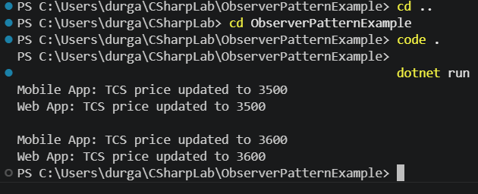
Exercise 8: Implementing the Strategy Pattern
using System;

interface IPaymentStrategy
{
void Pay(int amount);
}

class CreditCardPayment : IPaymentStrategy
{
public void Pay(int amount)
{
Console.WriteLine("Paid " + amount + " using Credit Card");
}
}

class PayPalPayment : IPaymentStrategy
{
public void Pay(int amount)
{
Console.WriteLine("Paid " + amount + " using PayPal");
}
}

class Payment
{
private IPaymentStrategy strategy;

public Payment(IPaymentStrategy strategy)
{
this.strategy = strategy;
}

public void MakePayment(int amount)
{
strategy.Pay(amount);
}
}

class Program
{
static void Main()
{
Payment payment1 = new Payment(new CreditCardPayment());
payment1.MakePayment(5000);

Payment payment2 = new Payment(new PayPalPayment());
payment2.MakePayment(3000);
}
}
Output-
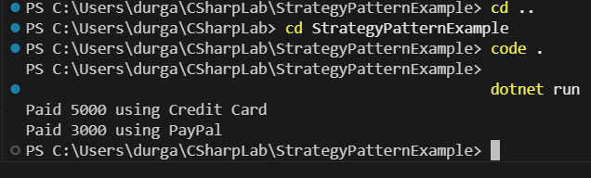
Exercise 9: Implementing the Command Pattern
using System;

interface ICommand
{
void Execute();
}

class Light
{
public void On()
{
Console.WriteLine("Light is ON");
}

public void Off()
{
Console.WriteLine("Light is OFF");
}
}

class LightOnCommand : ICommand
{
private Light light;

public LightOnCommand(Light light)
{
this.light = light;
}

public void Execute()
{
light.On();
}
}

class LightOffCommand : ICommand
{
private Light light;

public LightOffCommand(Light light)
{
this.light = light;
}

public void Execute()
{
light.Off();
}
}

class RemoteControl
{
public void Submit(ICommand command)
{
command.Execute();
}
}

class Program
{
static void Main()
{
Light light = new Light();

ICommand on = new LightOnCommand(light);
ICommand off = new LightOffCommand(light);

RemoteControl remote = new RemoteControl();

remote.Submit(on);
remote.Submit(off);
}
}
Output:
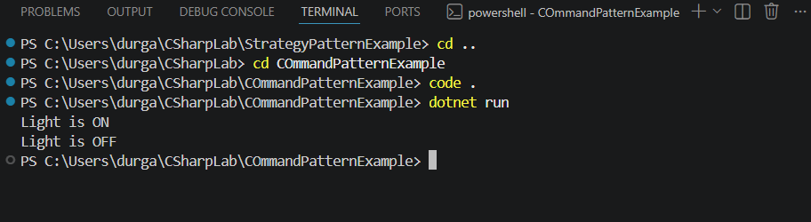
Exercise 10: Implementing the MVC Pattern
using System;

class Student
{
public string Name;
public int RollNo;

public Student(string name, int rollNo)
{
Name = name;
RollNo = rollNo;
}
}

class StudentView
{
public void Display(string name, int rollNo)
{
Console.WriteLine("Student Name: " + name);
Console.WriteLine("Student Roll No: " + rollNo);
}
}

class StudentController
{
private Student model;
private StudentView view;

public StudentController(Student model, StudentView view)
{
this.model = model;
this.view = view;
}

public void UpdateView()
{
view.Display(model.Name, model.RollNo);
}
}

class Program
{
static void Main()
{
Student student = new Student("Durga", 101);

StudentView view = new StudentView();

StudentController controller =
new StudentController(student, view);

controller.UpdateView();
}
}
Output-
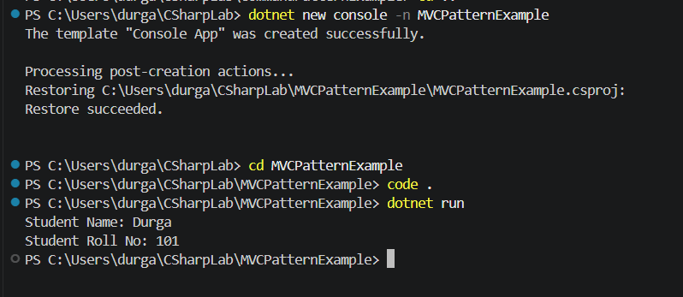
Exercise 11: Implementing Dependency Injection
using System;

interface ICustomerRepository
{
string GetCustomer();
}

class CustomerRepository : ICustomerRepository
{
public string GetCustomer()
{
return "Customer ID: 101, Name: Durga";
}
}

class CustomerService
{
private ICustomerRepository repository;

public CustomerService(ICustomerRepository repository)
{
this.repository = repository;
}

public void DisplayCustomer()
{
Console.WriteLine(repository.GetCustomer());
}
}

class Program
{
static void Main()
{
ICustomerRepository repository = new CustomerRepository();

CustomerService service = new CustomerService(repository);

service.DisplayCustomer();
}
}
Output-
